Hands On Lab 2
Expose RESTful APIs around Spring Data Repositories

This guide will help you expose RESTful API using a combination of Spring Boot, JPA/Hibernate, Spring Data and Spring Data REST. We will use H2 as the in memory database.

You will learn
- How to create a project using Spring Boot, Spring Boot Starter JPA, Spring Boot Data Rest Starter and H2?
- How to expose RESTful API using Spring Boot Data Rest?
- How to connect a Spring Boot project to database using JPA/Hibernate?
- How to create a simple JPA Entity with a primary key?
- How to write a simple repository interface extending JpaRepository interface?

Project Code Structure
Following screenshot shows the structure of the project we will create.
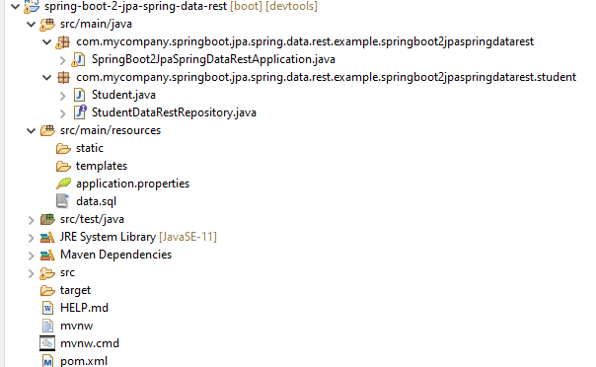

A few details:
- Student.java - Entity bean to store student details.
- StudentDataRestRepository.java - Extends PagingAndSortingRepository. Acts as a @RepositoryRestResource to provide RESTful API/Services to update/retrieve Student entities.
- data.sql - We use data.sql to populate the initial student data.
- SpringBoot2JPAWithSpringDataRestApplication.java - The main Spring Boot Application class which is used to launch up the application.
- pom.xml - Contains all the dependencies needed to build this project. We will use Spring Boot Starter JPA, Spring Boot Data REST Starter and Spring Boot Starter Web other than Developer Tools and H2 as in memory database.

Tools you will need
- Maven 3.0+ is your build tool
- Your favorite IDE. We use Spring Tool Suite.
- JDK 11

Big Picture - How does Spring Data REST Work?
Let’s start with JPA before moving onto Spring Data and Spring Data REST.

JPA
JPA allows to map application classes to tables in database.
- Entity Manager - Once the mappings are defined, entity manager can manage your entities. Entity Manager handles all interactions with the database
- JPQL (Java Persistence Query Language) - Provides ways to write queries to execute searches against entities. Important thing to understand is the these are different from SQL queries. JPQL queries already understand the mappings that are defined between entities. We can add additional conditions as needed.
- Criteria API defines a Java based API to execute searches against databases.

What is Spring Data?
From http://projects.spring.io/spring-data/
Spring Data’s mission is to provide a familiar and consistent, Spring-based programming model for data access while still retaining the special traits of the underlying data store. It makes it easy to use data access technologies, relational and non-relational databases, map-reduce frameworks, and cloud-based data services.
To make it simpler, Spring Data provides Abstractions (interfaces) you can use irrespective of underlying data source.
An example is shown below
interface TodoRepository extends CrudRepository<Todo, Long> {
Core idea is that
You can define a simple repository and use it to insert, update, delete and retrieve todo entities from the database - without writing a lot of code.

Spring Data REST
Spring Data REST can be used to expose HATEOAS RESTful resources around Spring Data repositories.
An example using JPA is shown below
@RepositoryRestResource(collectionResourceRel = "todos", path = "todos")
public interface TodoRepository
extends PagingAndSortingRepository<Todo, Long> {

Without writing a lot of code, we can expose RESTful API around Spring Data Repositories.
A few example REST Services that are automatically exposed
are shown below:

POST
- URL : http://localhost:8080/todos
- Use Header : Content-Type:application/json
Request Content
{
"user": "Jill",
"desc": "Learn Hibernate",
"done": false
}
Response Content
{
"user": "Jill",
"desc": "Learn Hibernate",
"done": false,
"_links": {
"self": {
"href": "http://localhost:8080/todos/1"
},
"todo": {
"href": "http://localhost:8080/todos/1"
}
}
}
The response contains the href of the newly created resource.

GET
- URI - http://localhost:8080/todos
Response
{
"_embedded" : {
"todos" : [ {
"user" : "Jill",
"desc" : "Learn Hibernate",
"done" : false,
"_links" : {
"self" : {
"href" : "http://localhost:8080/todos/1"
},
"todo" : {
"href" : "http://localhost:8080/todos/1"
}
}
} ]
},
"_links" : {
"self" : {
"href" : "http://localhost:8080/todos"
},
"profile" : {
"href" : "http://localhost:8080/profile/todos"
},
"search" : {
"href" : "http://localhost:8080/todos/search"
}
},
"page" : {
"size" : 20,
"totalElements" : 1,
"totalPages" : 1,
"number" : 0
}}

Creating the Project with Spring Initializr
Spring Initializr http://start.spring.io/ is great tool to bootstrap your Spring Boot projects.
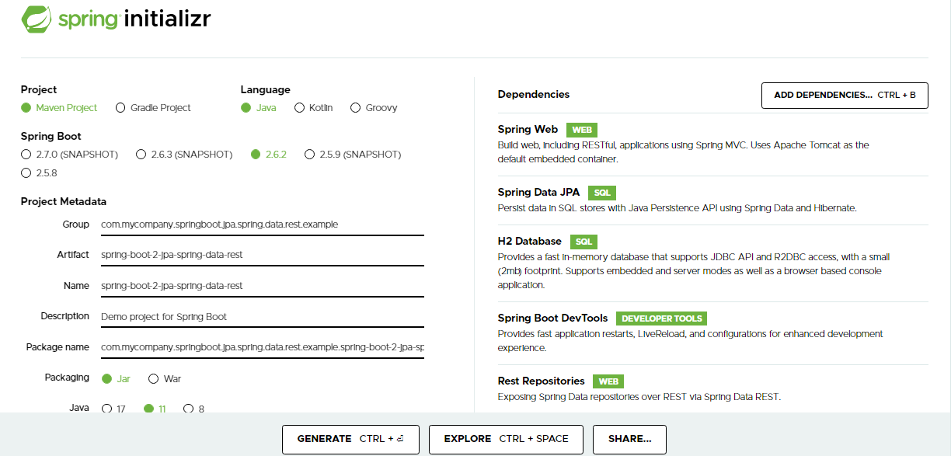
As shown in the image above, following steps have to be done
- Launch Spring Initializr and choose the following
  - Choose com.mycompany.springboot.jpa.spring.data.rest.example as Group
  - Choose spring-boot-2-jpa-spring-data-rest as Artifact
  - Choose following dependencies
    - Web
    - JPA
    - H2
    - DevTools
    - Rest Repositories
- Click Generate Project.
- Extract the downloaded file.
- Import the project into Eclipse. File -> Import -> Existing Maven Project.
Do not forget to add the dependency on “Rest Repositories” i.e. Spring Boot Data Rest Starter.

Starter Projects in pom.xml
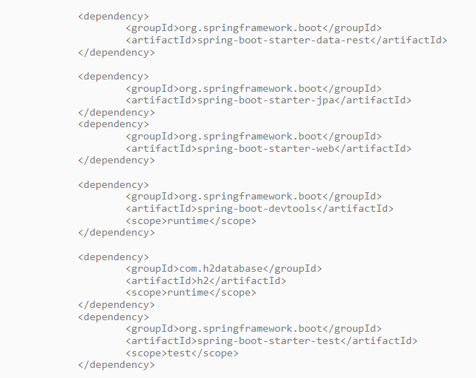

Understanding Spring Boot Starter Data Rest
Below image highlights some of the dependencies that are part of the imported Spring Boot project.
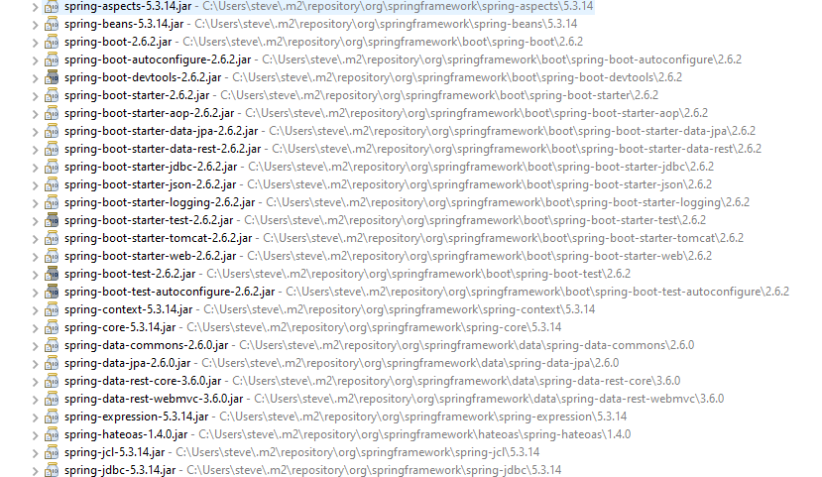

Key Question : How did all these dependencies come in?
All these dependencies are defined in spring-boot-starter-jpa and spring-boot-starter-data-rest. As soon as we include them in our project (pom.xml), we get the following features from a wide variety of dependencies
- Spring Data
- Spring Data Rest
- AOP
- Transaction Management
- JPA API
- JPA Implementation - Default Hibernate
- JDBC
Extract below shows some code from pom.xml of spring-boot-starter-data-rest.
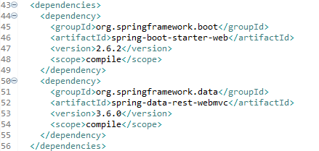

Enable H2 Console
We will use H2 as the database.
H2 provides a web interface called H2 Console to see the data. Let’s enable h2 console in the application.properties.
/src/main/resources/application.properties
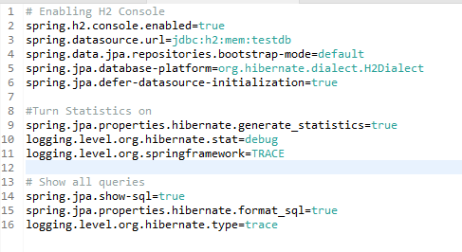

When you reload the application, you can launch up H2 Console at http://localhost:8080/h2-console.
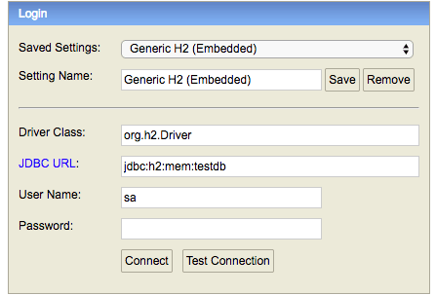
Tip - Make sure that you use jdbc:h2:mem:testdb as JDBC URL.
When you use the right JDBC URL given above, you should see an empty schema when you click Connect button. 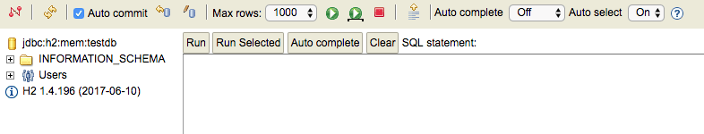

Create Your First JPA Entity
The first step is to create a JPA Entity. Lets create a simple Student Entity with a primary key id.
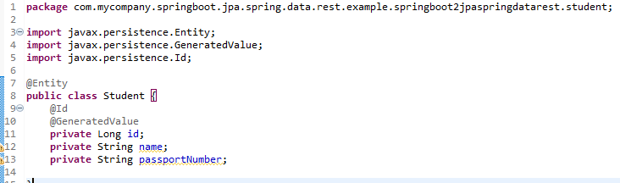

From the Source menu option:
- Generate getters and setters
- Default and parametrized constructors
- toString() method

Important things to note:
- @Entity: Specifies that the class is an entity. This annotation is applied to the entity class.
- @Id: Specifies the primary key of an entity.
- @GeneratedValue: Provides for the specification of generation strategies for the values of primary keys.
- public Student(): Default constructor to make JPA Happy
When the application reloads, you can launch H2 console at http://localhost:8080/h2-console.
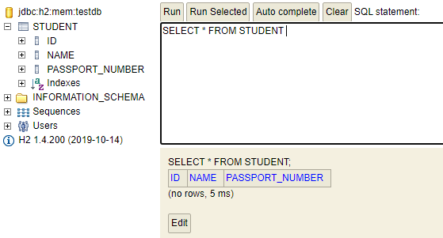
You will see that a new table called ‘student’ is created in H2 Console.
How did the Student table get created?
Its because of Spring Boot Auto Configuration.
Let’s now populate some data into the student table.
Create data.sql unders ‘src/main/resources’.
/src/main/resources/data.sql
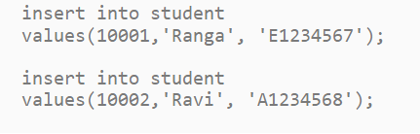
After App Reload, When you login to H2 Console (http://localhost:8080/h2-console) you can see that the student table is created and the data is populated.
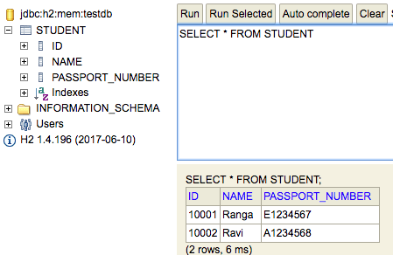

Create Spring Data Rest Repository class to expose Student API
Code below shows the Spring Data Rest Repository to expose API around the Student resource.
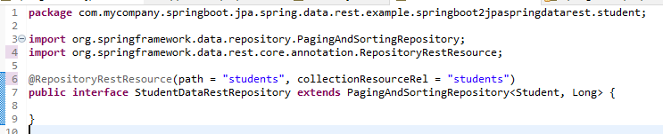

RepositoryRestResource annotation is used to expose Spring Data Rest services
A number of URIs with varied request methods are now exposed by Spring Data Rest. In the next section, we will explore all these resources.

Autowire Spring Data Rest Repository class in main application class
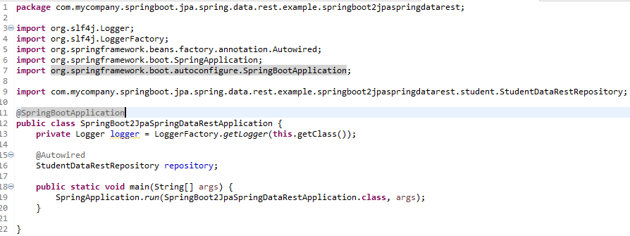

RESTful APIs exposed by Spring Data Rest
In this section, lets look at some of the Resource URIs that are exposed by Spring Data Rest.

Spring Data Rest API - Get All Data for Resource
localhost:8080/students

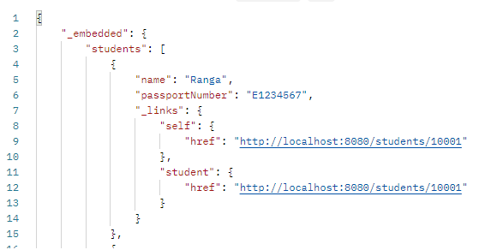

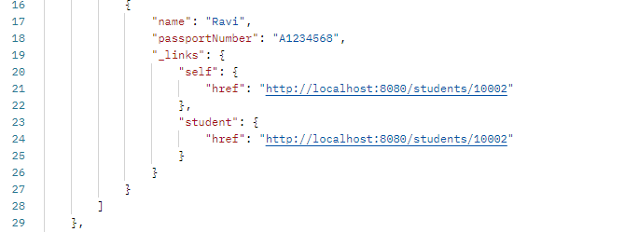
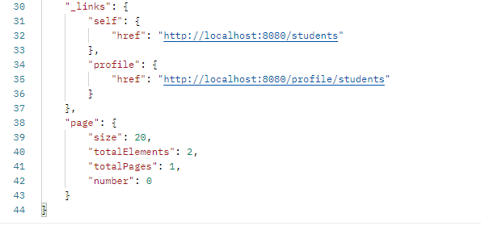

Notes:
- _embedded - Details of all students are part of this JSON element.
- _links - This section contains the links to other related resources - HATEOAS.
- page - This section contains the details of current page if we are using pagination. For example - http://localhost:8080/students?page=1 (0 indexed) will retrieve the second page of results. In this case, the page will be empty.
- Support for sorting - http://localhost:8080/students?sort=passportNumber : Sort by passport number. Ravi would appear in the results before Ranga because his passport starts with “A”.

Student RESTful API - POST Method
- URI - http://localhost:8080/students
- Request Method - POST
- Content-Type - application/json
Request Body Content
{
"name": "Adam",
"passportNumber": "Z1234567"
}

When we execute the above request, a new student is created.
Response
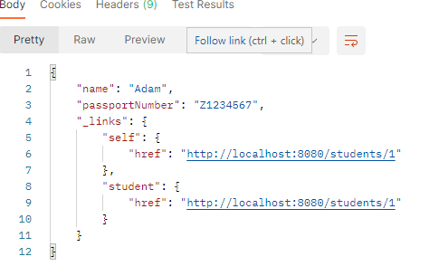
The response contains the URI to the created resource. Response Status - 201 CREATED.
Screenshot below shows a screenshot of executing the POST request using POSTMan
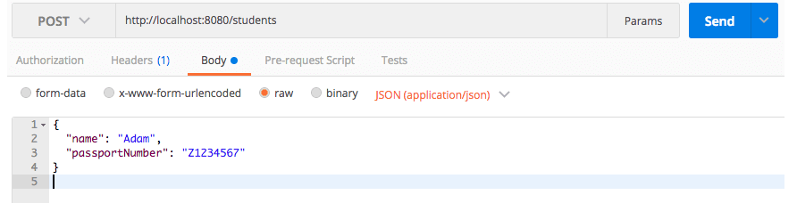

Student RESTful API - GET Method
- URI - http://localhost:8080/students/1
- Request Method - GET
When we execute the above request, details of a student are retrieved.
Response
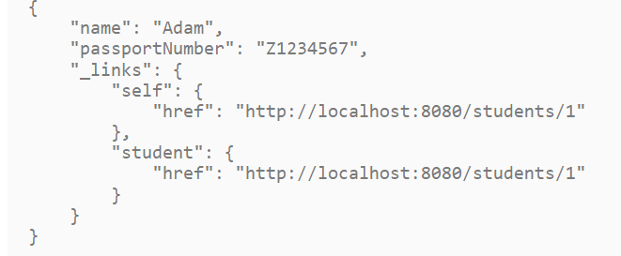

Student RESTful API - PUT Method
Used to update the details of a Student
- URI - http://localhost:8080/students/1
- Request Method - PUT
- Content-Type - application/json
Request Body Content
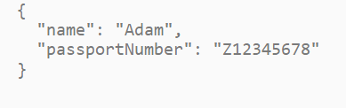
When we execute the above request, student details are updated.

Response
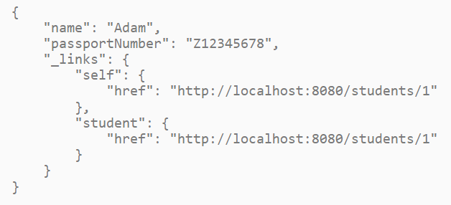
The response contains the URI to the updated resource.

Student RESTful API - Delete Method
- URI - http://localhost:8080/students/1
- Request Method - DELETE
Student 1 is deleted.

ALPS REST API for Resource Semantics
ALPS is a data format for defining simple descriptions of application-level semantics, similar in complexity to HTML microformats. An ALPS document can be used as a profile to explain the application semantics of a document with an application-agnostic media type (such as HTML, HAL, Collection+JSON, Siren, etc.). This increases the reusability of profile documents across media types.
- URI - http://localhost:8080/profile/students

Response
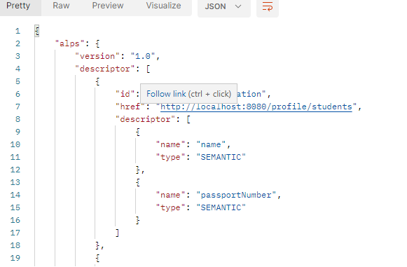
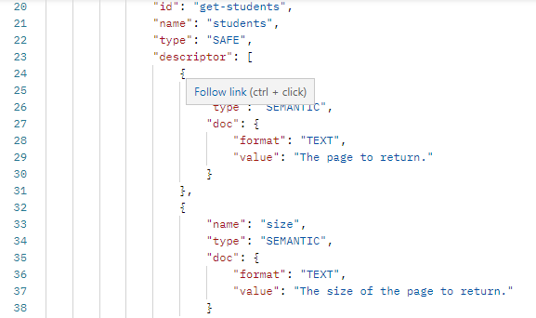
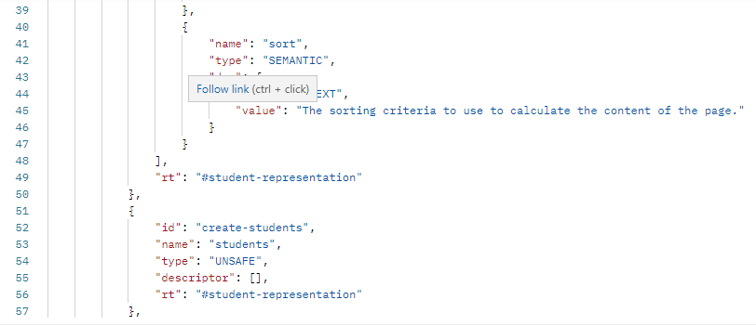
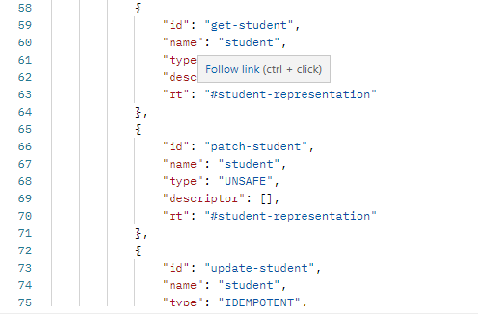
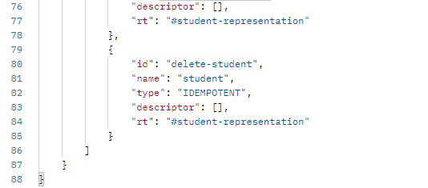

Other Features
Some of the other features of spring data rest include
- Paging and Sorting
- Customizing Serialization with Jackson’s ObjectMapper
- Projections
- Validation
- Security
- CORS Configurability
Refer to official documentation of Spring Data Rest for more details - https://docs.spring.io/spring-data/rest/docs/3.0.2.RELEASE/reference/html/

***************************************************************************************************************************

